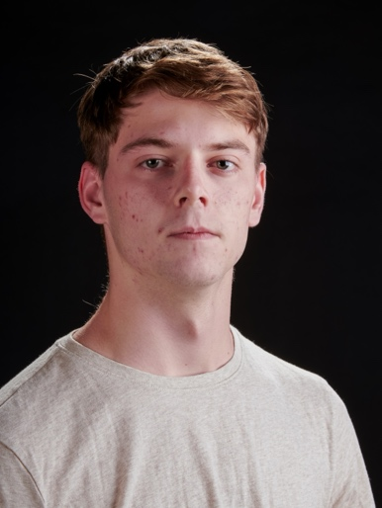

Cameron Damesworth

(517) 599-4039

Camerondamesworth@gmail.com

**Height**: 5’11” **Weight**: 149lbs **Hair**: Brown **Eyes**: Hazel

Non-union

**Theatre**

Newsies

The Spitfire Grill

The Seagull

Peter Pan jr.

Mary Poppins

Elf: The Musical

Little Women

A Year with Frog & Toad

**Film**

Wilderness Trip

**Training**

Musical Theatre (BFA)

Musical Theatre Dance Styles

Voice Lesson

Method study in mask characterization

On Camera Acting Workshop

Crutchie

Joe Sutter (understudy)

Medvedenko

Captain Hook

Bert

Buddy

Laurie

Frog

Isaac (Lead)

Taylor University

Kory Browder

Conor Angell

Tracy Manning

AJ Links

Tracy Manning

Conor Angell

Tracy Manning

Christine Hall

Amanda Wilson

Chase Schaffer

Cole Groot

Amanda Wilson

Aidan Merck

(In Progress)

**Awards**

Irene Ryan nomination for role of Medvedenko, NATS competition 2nd Place, Taylor University Musical Theatre Scholarship, voted most dedicated actor for Newsies.

**Special Skills**

Singing (Tenor, A2-C5), Dialects (British, Southern, New York), Sports experience (basketball, baseball, soccer, Disc Golf), Crutch mobility, Piano

